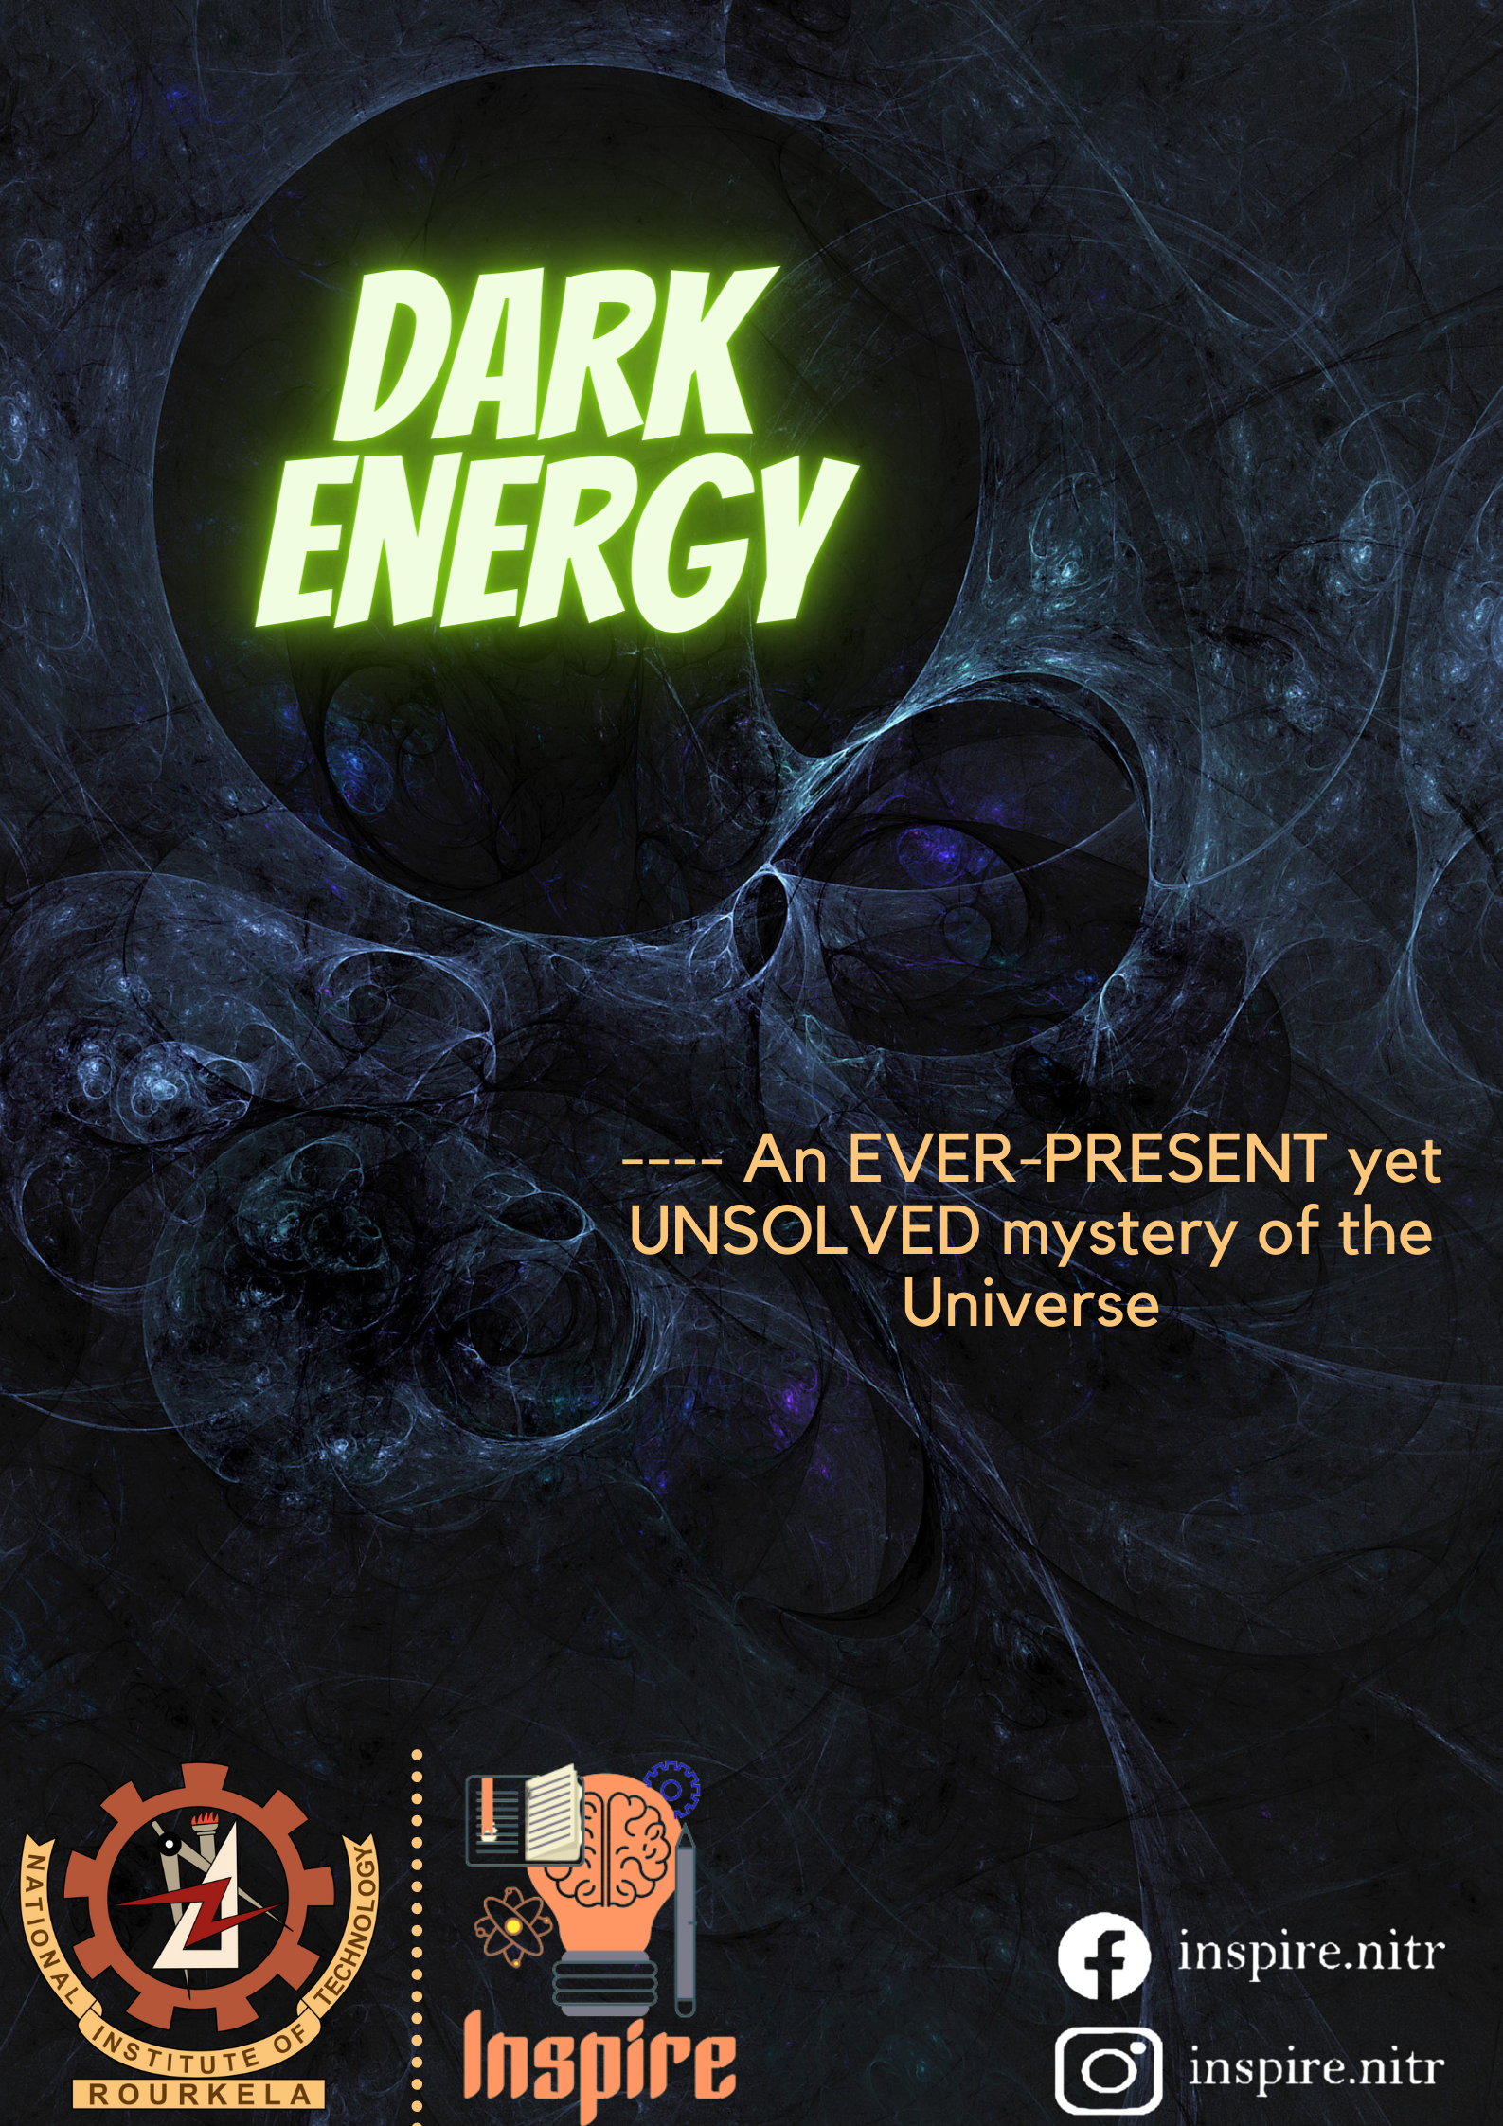

***I***n the early 1990s, the Big-Bang theory for the Origin of the Universe had already been widely accepted by the science community and it was clear that the Universe is Expanding rather than being stagnant. Still, the one certain question unanswered was “How?”. The hot topic for discussion back then was that the Universe might have enough energy density to stop its expansion or so little energy density that it would never stop expanding; and to be honest, we are yet to have a full proof answer to that. According to all the observable data available at that time, the Universe was believed to be full of matter and Gravity is what pulls all matter together. Thus, theoretically, the Universe had to slow down, but the slowing had not been observed. In **1998**, a major breakthrough to this aspect was achieved after the **Hubble Space Telescope (HST)** observations of very distant Supernovae concluded that the universe has not been slowing due to gravity but it was accelerating. At that time nobody even expected this neither knew how to explain it.

By studying many supernovae at different distances, theorists came up with some sorts of explanations. The most eye-catching speculations among them was that either Einstein’s theory of gravity must be somehow wrong to a very significant extent, or there may exist some strange kind of **Energy Fluid** which is responsible for the observed Gravitational Anomalies. Hence, efforts towards developing a new theory were made that could include some kind of field that creates this **Cosmic Acceleration**. At that time, the scientists didn’t know what the correct explanation is, but they gave the solution a name and that’s what they named it as **Dark Energy.**

**[The term ‘Dark Energy’ was coined by Michel Turner in 1998]**

***Components of the Universe:***

First of all, we should not be confused with **Dark Energy** and **Dark Matter.** Those two terms are totally incompatible.

* ***Dark energy:*** It is a complete mystery. The universe consists of dark energy which is approximately 68% while dark matter is about 27% and normal matter is about less than 5% of the universe. One of the explanations for dark energy was that it is a property of space. It is one of the unsolved mysteries of cosmology.
* ***Dark matter:*** It is a form of matter i.e. composed of particles which does not interact with electromagnetic field and hence it is called dark. It can’t be seen directly and it do not absorb, reflect or emit light, so by observing Electromagnetic Radiation, Dark Matter cannot be detected.
* ***Ordinary matter:*** Basically, Ordinary/Normal Matter is the stuff that we are made of. On a scientific note, on the scale of Elementary Particles, ordinary matter is defined as everything that is composed of Quarks and Leptons. The small-scale electrons, protons, neutrons etc., the mid-scale plants, animals etc. as well as the large-scale planets, stars etc. are all a part of Normal Matter.

***History and different proposed hypothesis:***

In the late 1990s, astronomers conclude that the expansion of the universe was not slowing down due to gravity as predicted earlier. Instead, the expansion speed was increasing and hence there must be something which favours this accelerating universe and was called “Dark Energy”.

Hubbleplayed an important role in verifying, characterizing and constraining Dark Energy. The discovery of **Supernova 1997ff**, located about 10 billion light-years away provided instrumental evidences for dark energy.

About several billion years ago, dark energy became dominant and the expansion accelerated. This accelerating period was measured from the ground-based studies while Hubble’s observation of 1997ff gives the decelerating part of the expansion. This change from a **decelerating universe to an accelerating universe** showed that dark energy exists.

An explanation for dark energy gives us an idea that it will be a new kind of **dynamic energy fluid or field**. It was predicted that there exists something which fills the space but at the same time its expansion of the universe is the opposite to that of matter and normal energy.

A last possibility suggested was that Einstein’s theory of gravity is not completely correct. This will not only affect the expansion of the universe but it would also affect the way that the normal matter in galaxies behaves. So, it was suggested that the solution to dark energy can be a major modification to the existing gravity theory but it will be a challenge to the existing universe at the same time. How it will describe the motion of the bodies correctly as Einstein’s theory is known to do? Hence, a lot of drawbacks arise and the mystery of this dark energy continues.

***Evidences of Dark energy:***

The evidence for dark energy is indirect but comes from three independent sources:

* Distance measurements and their relation to **Red-shift** [a practical result of Doppler’s effect in Light] which suggest the universe has expanded more in the last half of its life.
* The theoretical need for a type of additional energy that is not matter or dark matter to form the Observationally Flat Universe (absence of any detectable Global Curvature).
* Measures of **large-scale wave-patterns** of mass density in the universe.

There are some phenomena that provide crucial evidences towards the existence of Dark Energy. Some of those are –

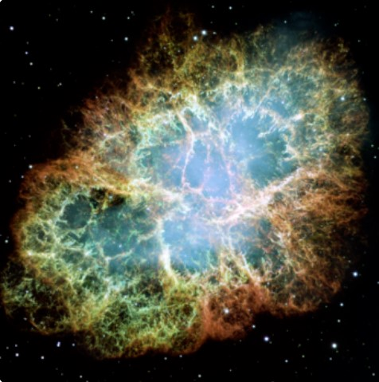***(1) Supernovae:***

A Supernova is a powerful and luminous stellar explosion. This transient astronomical event occurs during the last evolutionary stages of a massive star. This happens when a star at least five times the mass of our sun goes out with a fantastic bang! Supernovae give us evidence for galaxies moving away from us by calculating their redshift. This redshift shows that something is causing the galaxies to **move away** at an accelerated rate **(resisting gravity more and more)**, which points to dark energy.

***(2) Cosmic Microwave Background:***

The Cosmic Microwave Background (CMB), in Big-Bang cosmology, is the **oldest electromagnetic radiation** which is a remnant from an early stage of the universe. Results from **CMB spectrum** are the most important for the evidence of existence of Dark Energy. The existence of dark energy, in whatever form, is needed to reconcile the measured geometry of space with the total amount of matter in the universe. Measurements of CMB anisotropies indicate that the universe is close to flat. For the shape of the universe to be flat, the mass-energy density of the universe must be equal to the critical density (the average density of matter required for the Universe to just halt its expansion, but only after an infinite time). Thus, dark energy is needed to fill out the remaining mass-energy. The total amount of matter in the universe (including normal matter and dark matter) as measured from the CMB spectrum, accounts for only about 30% of the critical density. This implies the existence of an additional form of energy to account for the remaining 70%. The accurate estimate of 68.3% dark energy, 26.8% dark matter and 4.9% ordinary matter, given by **Plank Spacecraft** in 2013, are indeed the observations of CMB.

***(3) Sachs – Wolfe effect:***

A significant report was published in 2008 that had a typical evidence for the existence of Dark Energy. Accelerated cosmic expansion causes **Gravitational Potential curve** elevations and depressions to flatten as photons pass through them, producing cold spots and hot spots on the CMB spectrum. This so-called late-time **Integrated Sachs – Wolfe effect (ISW)** is a direct signal of dark energy in a flat universe.

***(4) Gravitational Lensing:***

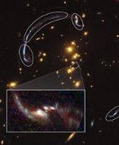Gravitational lensing occurs when the light from a distant object, such as a **Quasar** (an extremely luminous active galactic nucleus (AGN), in which a supermassive black hole with mass ranging from millions to billions of times the mass of the Sun is surrounded by a gaseous accretion disk) is bent by the gravitational field of another object on its journey to Earth. By the analysis of the various surveys by Cosmic Lens All Sky Survey (CLASS) about distribution of energies across many galaxies, it was that found most of the energies in the universe are dark energies.

***Nature of ‘DARK ENERGY’:***

The nature of Dark Energy inclines more to the hypothetical aspects and is a product of seamless speculations. It uniformly occupies a major 68% empty space of the total Universal Mass-Energy content. Despite of its profound effects on the universe and abundant existence, it is quite **dilute** and un-massive as the estimated value of density is roughly around ${10}^{-27} kg/m^{3}$. This is one of the major reasons behind the failure of its detection in laboratory experiments. Dark Energy is thought to be **homogeneous** and not very dense. Gravity is the only of the four ‘Fundamental Forces’ (interactions that do not appear to be reducible to more basic interactions) that works as the method of interaction between Dark Energy and the phenomena related to it.

There are evidences of the fact that the Universe is expanding, but there is no physical explanation to its reason even though there are mathematical accounts to it. Thus, a possible **positive potential energy** i.e. ‘Dark Energy’ is used to explain the accelerated expansion of the Universe. According to general relativity, the pressure within a substance contributes to its Gravitational interaction with other objects just as its mass density does. We define the ‘Stress-Energy tensor’ [containing both Energy (or matter) density of a substance as well as its pressure and viscosity] as the physical quantity that causes matter to generate gravitational effects. In order to describe this accelerating expansion effect (also known as ‘Gravitational Repulsion’) the Dark Energy would need to have a **strong negative pressure** i.e. repulsive action.

For a Universe of given mass density, how the expansion of the Universe has changed over time, gives us the information on the amount and nature of Dark Energy. Dark Energy affects two things

* Distances of expansion of Universe
* Growth of concentration of matter

These are the nature of Dark Energy discovered by measuring how Dark Matter has accumulated gravitationally in the giant structures over history of Universe and how the ratios of distances have grown with Cosmic Time.

There is also a possibility that the development of mass structures via ordinary gravitationally-induced accumulation will have slowed over time as the accelerated expansion of Universe is a result of existence of this Dark Energy. The rate of that slowing, if found, can be sensitive to the physical nature of this Dark Energy itself. Therefore, it can’t be ignored that the so-called **Equation of State** i.e. the outward pressure exerted by the matter divided by how much of this matter is there, essentially is telling us how much influence Dark Energy can wield at any given time.

***Technical Definition:***

In standard cosmology, there are three components of the Universe i.e. matter, radiation and dark energy. We define ‘a’ **(scale factor)** as the number by which all the components of an object are multiplied in order to create a proportional enlargement or reduction. We also define ‘ $ρ$’ as the energy density. Now we can describe the Cosmological components as

* ***Matter:*** Matter is anything whose energy density scales with the inverse cube of the scale factor i.e. $ρ α a^{-3}$
* ***Radiation:*** Radiation is anything whose energy density scales to the inverse fourth power of the scale factor i.e. $ρ α a^{-4}$
* ***Dark Energy:*** It is an intrinsic property of space and so has a constant energy density regardless of the volume under consideration i.e. $ρ α a^{0}$ Thus, unlike ordinary matter, Dark Energy does not get diluted with the expansion of space.

***Theories regarding ‘DARK ENERGY’:***

Initial research into the extraordinary sector of Dark Energy revealed some astonishing results. Dark energy is a **property of space** and Einstein realized that space is “not” nothing but it has amazing properties. He discovered that it is possible for more space to came into existence.

Dark energy's status as a hypothetical force with unknown properties makes it a very active target of research. Many theories have been suggested that deals with the origin, existence, nature and function of Dark Energy. Some of them are as follows.

***(1)*** ***Cosmological Constant*:**

The simplest explanation for dark energy is that it is an intrinsic, fundamental energy of space. This is the cosmological constant, usually represented by the Greek letter ‘Λ’ (Lambda). In Cosmology, the Cosmological Constant is the energy density of space or **Vacuum Energy**, that arises in Einstein’s field equations of general relativity. It is closely associated to the concepts of Dark Energy. After Einstein constructed General Relativity in 1915–1916, he tried to apply his theory to the Universe in 1917. In the absence a constant, the scale factor ‘a’ can dynamically change in time. Around 1920, however, Einstein believed that the Universe was static and introduced the cosmological constant to realize such a Universe. The Cosmological Constant ‘Λ’ works as a **repulsive force against gravity** at the background level. Einstein described it as

$Λ=4πρG$ (G = Universal gravitational constant)

This equation, the first relativistic cosmology ever, shows that the density ρ in the Universe is determined by Λ.

Despite its simplicity, it is generally difficult to explain why the energy scale of the cosmological constant required for the cosmic acceleration today, is very small relative to that predicted by particle physics. There are two major advantages for the cosmological constant. The first is that it is simple. Hubble found that the universe is expanding, so, a **“non-zero” cosmological constant** can act as Dark Energy, without otherwise changing the Einstein field equations. The other advantage is that there is a natural explanation for its origin. Most ‘Quantum Field Theories’ predict ‘**Quantum Fluctuations**’ (the temporary random change in the amount of energy in a point in space) that would give the vacuum this sort of energy.

The cosmological constant has **negative pressure** equal and opposite to its energy density and thus causes the expansion of the universe to accelerate. The reason a cosmological constant has negative pressure can be seen from classical thermodynamics. We know that the amount of energy in a container full of vacuum actually increases when the volume increases, because the energy is equal to *ρV* [instead of −*P (dV)* as in regular cases] where *ρ* is the energy density of the cosmological constant. Therefore, *ρ* is negative and, in fact, *ρ* = − P

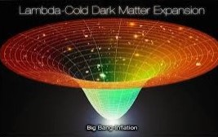 The cosmological constant is the most economical solution to the problem of cosmic acceleration. Thus, the current standard model of cosmology, the **Lambda-CDM model** [a parametric representation of the Big-Bang Cosmological model that considers three major components of the Universe i.e. Cosmological Constant, Dark Energy and Cold Dark Matter (85% of the total available Dark Matter)], includes the cosmological constant as an essential feature.

A prediction that came as a result of preliminary observations of the applications of Einstein’s theory of gravity containing cosmological constant, states that “Empty Space can possess its own energy and this energy results in expansion of universe faster and faster.” This prediction however is now backed by an explanation that comes from the **Quantum Theory of matter**. This theory suggests that the empty space is actually full of temporary particles that continuously forms and then disappears. Even with development of many prominent theories as well as constant research in that field, the Mysteries of Space are still to be completely unrevealed.

***(2) Modified Matter Models:***

There are basically two approaches for the construction of Dark Energy models. The first approach is based on “modified matter models”. The second approach is based on “modified gravity models”. It is however important to realize that within General Relativity this division is mostly a practical way to classify the variety of Dark Energy models but does not carry a fundamental meaning. ‘**Quintessence Model**’ is one of the “modified matter models”. Unlike the cosmological constant, the equation of state of Quintessence **dynamically changes with time**. The energy density of Quintessence does not need to be very small with respect to radiation or matter in the early Universe unlike the cosmological constant scenario.

We use the term “Quintessence” to denote a canonical scalar field with a potential that interacts with all the other components only through standard gravity. In Quintessence models of Dark Energy, the observed acceleration of the scale factor is caused by the potential energy of a dynamical field, referred to as ‘**Quintessence Field**’. The quintessence field has a density which closely tracks the radiation density, which triggers quintessence to start behaving as dark energy, eventually dominating the universe. This naturally sets the low energy scale of the dark energy.

Some special cases of Quintessence are **Phantom Energy**, in which the energy density of Quintessence actually increases with time, and **k-essence** (short for kinetic quintessence) which has a non-standard form of kinetic energy such as a **negative kinetic energy**. They can have unusual properties. All these models come under the “modified matter models” that describes the physical presence as well as function of Dark Energy.

***3) Modified Gravity Models:***

In “modified gravity” models, the origin of Dark Energy is identified as a modification of gravity. This includes f(R) gravity [One of the simplest modified gravity models in which the **4-dimensional action** is given by some **general function f(R)**; where R refers to the scalar curvature **(Ricci Scalar)** i.e. the simplest curvature invariant in Riemannian Geometry], Scalar-Tensor theories, Gauss–Bonnet gravity and Braneworld models of dark energy. In these theories one modifies the laws of gravity so that the late-time accelerated expansion of the Universe is realized without recourse to an explicit dark energy matter component. Clearly, the modification to the laws of gravity is in general severely restricted from local gravity constraints and from observational constraints. It is of interest to understand how much deviation from the ΛCDM model can be allowed in such modified gravity models.

***Universal Aspects:***

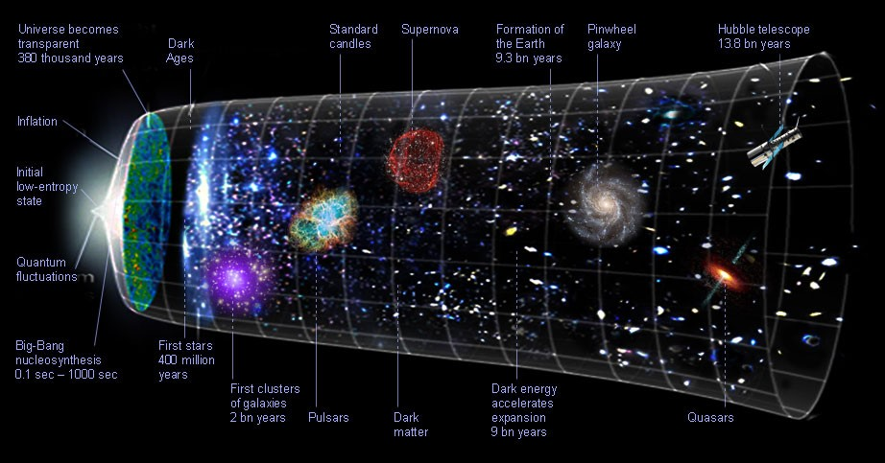Dark Energy is one of the few things that has significant impact in the history and the present and also a very important part to play in the future of the Universe itself. This can be better understood if we know the basic knowledge of the progression of the Universe.

* **The Big-Bang:** The Universe burst forth violently from an extremely hot and dense point of concentrated energy (including Dark Energy), about 13.8 billion years ago.
* **Inflation:** In about 10-33 part of a single second after the Big-Bang, the Universe ballooned outward, growing faster than the speed of light and pulling all the matter (normal and dark) and energy (Dark Energy) in the cosmos apart in all directions.
* **Uniform expansion of the Universe:** During the initial stages (till about the starting 9 billion years from Big-Bang) the Gravitational interactions were dominant over the Dark Energy, but still due to the momentum caused in the Inflation period, the Universe continued to expand in a slow way.
* **Accelerated expansion of the Universe:** A little more than 5 billion years ago, the repulsive effect of Dark Energy overpowered the attractive forces of Gravity on large scales. This caused the Universe to expand at a very significant increasing rate.
* **The Dark fate of the Universe:** After analysing all the evidences as well as the nature of both Dark Energy and the characteristics of our Universe, many possibilities, probabilities and prophecies about the fate of the Universe are proposed. Almost every one of them use the concept of Dark Energy to relate the Universe to its fate. A common proposal predicts that the expansion of the Universe will continue accelerating forever due to the existence of Dark Energy.

***Conclusion:***

There are still many problems to solve, many formulae to calculate, many mysteries to unfold about the Universe, but we can never deny the fact that Dark Energy is one of the most crucial components of it. It’s one of the most interesting as well as trending topic for the scientists and thus seamless research is still going on in this topic. Dark Energy is the part in our past, a companion of the present and also a determining factor for our future. The only thing left to see is how the mysteries of the Universe are going to reveal themselves.

***References:***

* General idea: <https://en.wikipedia.org/wiki/Dark_energy>
* Hubble Space Telescope and its contribution to discovery of Dark Energy: <https://hubblesite.org/contents/news-releases/2001/news-2001-09.html>
* <https://science.nasa.gov/astrophysics/focus-areas/what-is-dark-energy>
* Matter: <https://en.wikipedia.org/wiki/Matter>
* <https://en.wikipedia.org/wiki/Dark_energy#Evidence_of_existence>
* CMB: <https://en.wikipedia.org/wiki/Cosmic_microwave_background>
* CMB Spectrum: <https://asd.gsfc.nasa.gov/archive/arcade/cmb_spectrum.html>
* Supernova: <https://spaceplace.nasa.gov/supernova/en/>
* Gravitational Lensing: <https://www.science.org.au/curious/space-time/gravitational-lensing#:~:text=As%20the%20light%20emitted%20by,This%20is%20called%20gravitational%20lensing>.
* Evidences of Dark Energy: <https://quizlet.com/404858201/astr300_ch23-flash-cards/>
* Definition in Technical terms: <https://en.wikipedia.org/wiki/Dark_energy#Technical_definition>
* Nature of Dark Energy: <https://www.researchgate.net/publication/275351008_The_Nature_of_Dark_Matter_and_of_Dark_Energy>
* Dark Energy – Theory and observations – Luca Amendola and Shinji Tsujikawa – Chapters: 5, 6,7,8 and 9
* Dark Matter and Dark Energy – The hidden 95% of the Universe – Brian Clegg – Chapters: 4 and 5
* Dark Energy – Staring into darkness: <https://www.nature.com/articles/537S201a>
* LCDM Model: <https://en.wikipedia.org/wiki/Lambda-CDM_model>
* <https://www.worldscientific.com/doi/abs/10.1142/9789813231979_0010>
* f(R) gravity: <https://link.springer.com/article/10.1140/epjc/s10052-018-5681-8>
* Ricci’s constant: <https://en.wikipedia.org/wiki/Scalar_curvature#:~:text=In%20Riemannian%20geometry%2C%20the%20scalar,the%20manifold%20near%20that%20point>.
* <https://astronomy.com/magazine/2018/07/the-weird-mystery-of-dark-energy>
* Impact of Dark Energy in deciding the future of the Universe: <http://secretsoftheuniversefilm.com/dark-matter-and-dark-energy-explained-infographic/>